Low power system for LoRa end nodes.

# Introduction.

LoRa end nodes are often battery powered. In order to save battery usage the node is put into a deep sleep most of the time. The node awakes normally when data read from a sensor must be sent to the LoRa network.

In deep sleep mode, the node normally consumes 3 or more µA.

This document describes a power control system that consumes less than 1 µA during idle mode.

# Low power system.

The power supply presented here is designed to switch power on a fixed interval basis. The attached device (a LoRa end node) will be powered up, perform its task and then switch the power supply off.

The timing of the power-up interval is done by using a TPL5010 “Nano-power system timer”. The TPL5010 consumes only 35 nA in idle mode. The interval time can be set by means of a resistor to maximal 2 hours.

The end stage of the circuit is a P-channel MosFet (AO3407), capable of driving 3 A.

## Schematics.

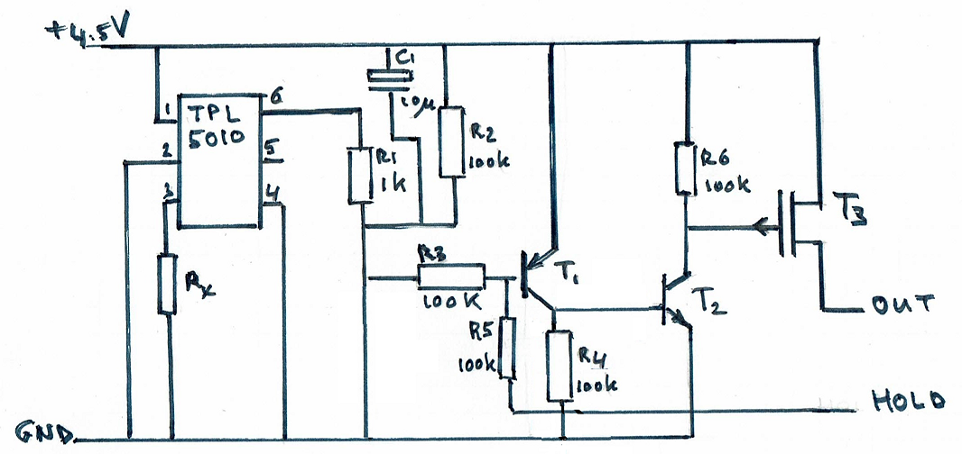

Fig. 1

Input power is 5.5 V max. None of the three transistors are conducting in idle mode. The capacitor C1 will be discharged in idle mode.

## Part list.

|  |  |
| --- | --- |
| TPL5010 | Nano-power system timer. 6 lead SOT23. |
| Rx | Timer interval selection, for example 57.44 kΩ for 10 minutes. For testing, use an 8.2 k resistor to create an interval of a few seconds. |
| R1 | 1 kΩ |
| C1 | 10 µF. Selects the minimal “ON”-time. |
| R2, R3, R4, R5, R6 | 100 kΩ |
| T1 | S9015 transistor PNP. |
| T2 | S9014 transistor NPN. |
| T3 | P-channel MosFet (AO3407), 30V, 3A, RDS < 87mΩ |

# Theory of operation.

The TPL5010 generates a “reset”-pulse of 320 msec on pin 6 (open collector). This pulse is too short to start a microcontroller, usually the power-on time is about 1 second. Therefore the pulse length is stretched to about 2.4 seconds by R2 and C1. The pulse is shaped by T1 and T3.

The interval depends on the value of Rx. See the datasheet of the TPL5010 for a table with time intervals. Note that changing the value of Rx has its effect after power-up of the circuit.   
The HOLD signal must be driven HIGH by the micro controller of the LoRA end node if the required processing time is longer than the duration of the stretched pulse. As soon as the end node has finished it job, the HOLD signal can be withdrawn, effectively turning the power system OFF.

# Prototype.

I made a prototype for this on a perfboard. It looks like this:

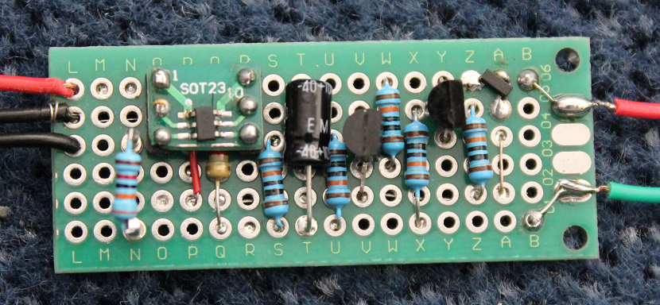

Fig. 2

The green wire is for the hold signal. The FET is in the top right corner, near the letter “A”. Rx is mounted on two pins for easy replacement. It is positioned near letter “N”.

The back side:

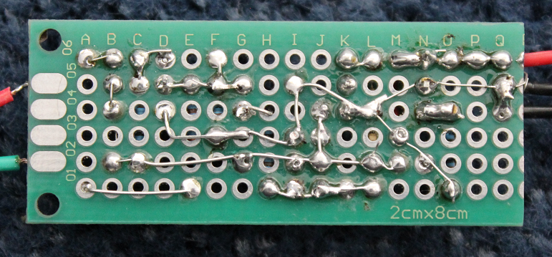

Fig. 3

# Power measurements.

I was not able to measure the idle power consumption, as I have a multimeter with a resolution of 1 micro ampere. After a few seconds the power consumption should theoretically be far below 1 µA.

# Useful extension.

You may add a button between pin 1 and 3 of the TPL5010 to start the power cycle manually.

# Limitations.

The end node is completely shut down in idle mode. The result is that there is no longer a battery backed-up memory available to store data. In LoRa end nodes this memory is often used to hold the sequence number (frame counter) of the messages to the LoRa network.  
So by using this power supply you have to be sure that the LoRa application at TTN does not expect an incrementing frame counter. So uncheck the “Frame counter Checks” of your device in the settings on the TTN console.

You may also use the flash memory to hold the frame counter. Normally the flash can withstand 100000 write operations, that’s at least 10 years if your node send data every hour. And probably 100 years if you do some wear-leveling.